[Leetcode: 5 Tricks To Solve Any Interval/Conflict Schedule Related Problems | by Cuong Phan | InterviewNoodle | Medium](https://medium.com/interviewnoodle/leetcode-5-tricks-to-solve-any-interval-conflict-schedule-related-problems-3f33d6e5af55)

## **1. Understand the basic interval relations**

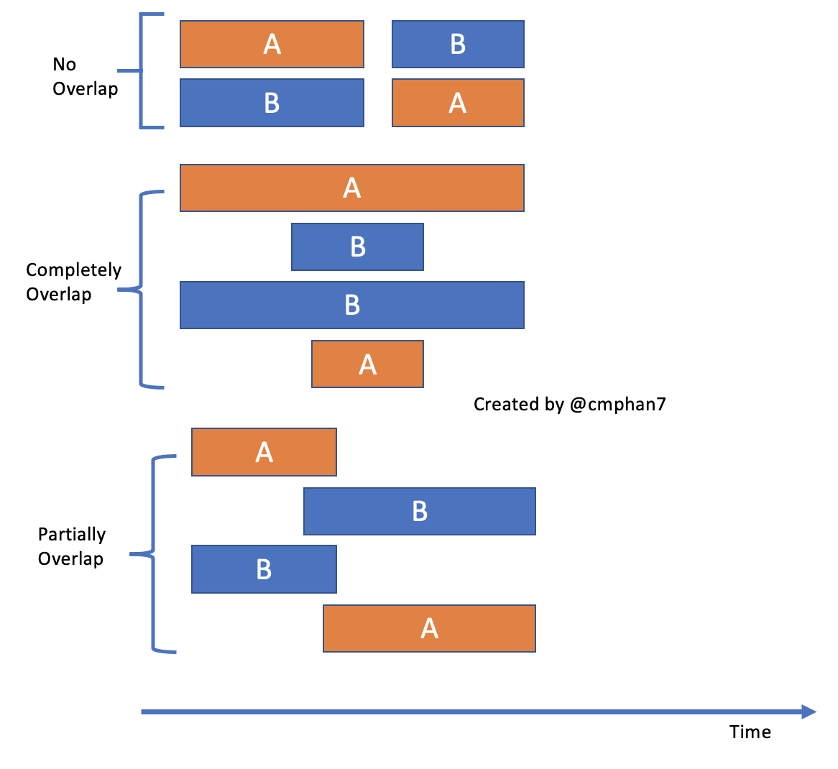

## **2. Sort the intervals first**

## Hence, only these 3 possibilities will be there:

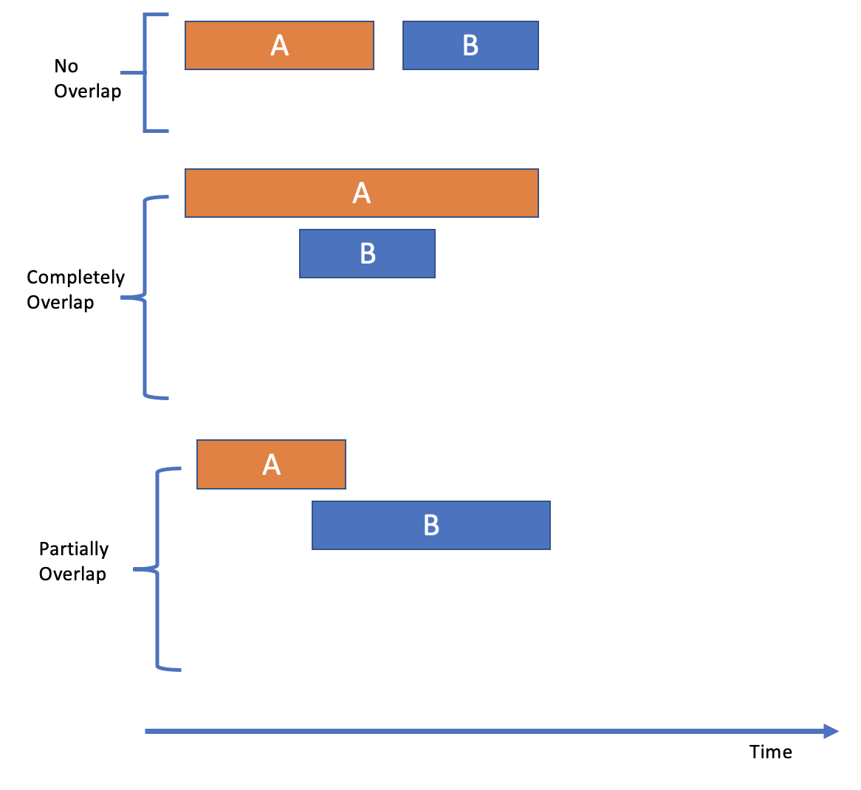

## **3. Understand the merge operation**

## Check if **b.start ≤ a.end** for **overlapping/mergeable**. => **mergedIntervalEnd = Math.max(a.end, b.end)**

**4. Understand the intersect operation**

Check if **Math.max(a.start, b.start) ≤ Math.min(a.end, b.end)**   
**=> intersectInterval = [Math.max(a.start, b.start), Math.min(a.end, b.end)]**